|  |
| --- |
| Comsats University Logo 1 - UpLabs |
| SOFTWERE TESTING |
| MUHAMMAD SHERAZ |
| **FA19-bse-160**  **Section :6th_D** |
| **6/25/2022** |

**ANSWER:**

**ANDROID APLLICATION TESTING:**

“Testing your app is an integral part of the app development process. By running tests against your app consistently, you can verify your app's correctness, functional behavior, and usability before you release it publicly. Testing also offers the following advantages: Rapid feedback on failures.”

**ANDROID APLLICATION TESTING STRATEGY KEY POINTS:**



In fact, this is really not easy to choose the most appropriate device. Anyway, here are some actions you should do while selecting device for the mobile testing:

* Make the analysis to define the most popular and used gadgets in the market.
* Choose devices with different OS.
* Choose devices with different screen resolutions.
* Pay attention to the next factors: compatibility, memory size, connectivity etc.

**MOBILE APPLICATION TESTING PHASE:**

So, let’s start to consider the main stages of the mobile app testing process. They more mostly similar to the website testing stages. Mostly, but not quite similar. As you have read before, there are some basic differences between mobile and desktop applications. Therefore, we need to pass some additional stages and make some additional verification.

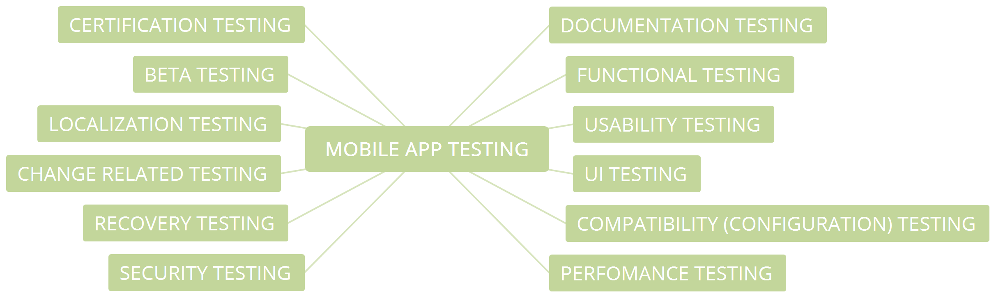

**KEY POINT FOR TESTING ANDROID APPLICATION:**

Let’s systematize our knowledge, and try to determine the main tips for mobile application testing.

* Learn the app you are going to test.
* Remember the differences between desktop and mobile apps.
* Take into account the operating system and hardware specifics
* Use real devices when it is possible.
* Don’t Try to Find the “Swiss Army Knife” of Testing. Use the tools you are familiar with.
* Use the advantages of the cloud mobile testing.
* Confirm your findings with screenshots, logs and videos.
* Provide your mobile app testing both for portrait and landscape screen mode.
* Use the development menu options for iOS and Android.
* Do not neglect (but do not abuse) emulators and simulators for testing.
* Verify perfomance of your app.
* Don’t automate everything
* Get real users to test your app
* Release the time to work out more complex, unconventional test scenarios (f.e. use test “monkeys”).
* Consider the human factor

**TOUCH UTILITY DRIVER:**

A touch screen device is used for direct manipulation of objects on the screen. Since the user is directly touching the screen, the system does not require any additional affordances to indicate the objects being manipulated

**ASSERTION FOR ANDROID APPLICATION TESTING :**

Assert is a Java keyword used to define an assert statement. An assert statement is used to declare an expected Boolean condition in a program. If the program is running with assertions enabled, then the condition is checked at runtime. If the condition is false, the Java runtime system throws an Assertion Error.

**MOCKS OBJECTS**

A mock object is the object that has properties of the real object while skipping the complications of creating a real object now.android.test.mock.MockContext. A mock Context class. All methods are non-functional and throw Unsupported OperationException . You can use this to inject other dependencies, mocks, or monitors into the classes you are testing.

**THE END**